Munster Technological University

COMP7039 – Agile Processes

CS3

October 2021

Individual Assessment – Git (20 %)

Name: Yeap Heng Wei

Class_Lab_Group: CS3

Please edit and submit this document.

Submission Instructions:

Submissions to be made on Canvas by:

17:40, October 21, 2021

- Zip your assignment folder containing THIS edited document complete with screenshots and a zip archive file of your git folder including the hidden .git folder.

- Name the compressed file using the following convention:

YourFirstName_YourLastName_YourLab_Group.zip
e.g.
John_OBrien_CS3.zip

Munster Technological University, MTU, is one of Ireland’s newest Universities. MTU wants to create a web page to promote the University and its education programmes across its numerous campuses. MTU wants its web page to be developed in stages, to facilitate the inclusion of emerging detail.

Create an initial web page and subsequently update it in stages, using git to manage the changes.

NB – You must show screenshots of all git commands executed!

- Create a very basic HTML home page document for the newly-formed Munster Technological University. The page contains the name “Munster Technological University” and its address.
Create and configure a git-managed repository and commit your initial version of the page.

- Add items to the web page, each time committing to the repository. In total, create and commit 5 variations of your web page. Consider the following example items-to-add: About, Latest News, Contact Details, University Philosophy, University Vision, Marine College, Kerry Campus, School of Music, College of Art & Design
- Add a second file to the repository e.g. a css file to change the look of the page. Commit that css file; also commit two revisions of the css file.
Additionally, revise the web page html code to use the css file. Commit your revised web page. Thus, there are now 7 versions of the web page.

- Demonstrate rolling back to view version 4, of the web page.

Create a branch from version 6; on your branch, modify the web page in order to demonstrate a new variation for the customer.

- Demonstrate merging, versioning and stashing

- Execute the following git commands and include screen shot(s) of all output generated.
git config –list
git log

NB:
“By submitting this electronically, using an account & password only I have access to, I hereby certify that this material which I now submit for assessment is entirely my own work and has not been taken from the work of others, save and to the extent, that such work has been cited and acknowledged within the text of my work.”

MTU has access to plagiarism tools and these may be used on submitted assignments. The use of ‘rent a coder’ type services in preparing your assignment is forbidden.

Demo
You may be asked to demo your assessment-work during your assigned Lab-session.

Screenshots
See below for example of screenshots to use when submitting this assignment – ensure the command prompt uses your login id/name or student ID.
Additionally, ensure that all screenshot details are clearly visible and easy-to-read.

Marks
Only work undertaken and completed by you, during your assigned Assessment 1 Lab-time, will be considered for marking.
Your Assessment 1 work must be submitted by or before the end of your assigned Assessment 1 Lab-time.

Good luck!
Place each item of the assignment on a separate page and show clearly readable screen shot(s) of how you achieved the task item. List steps executed to describe what you have done.

Example

Task “initialize a Git repository and set the user’s name and e-mail address”

1(a) Initialize a Git repository and set the user’s name and password.

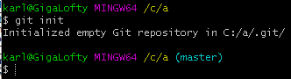

Description:
Use the git init command to create an empty git repository.

Enter the git config command to set the username and email address:

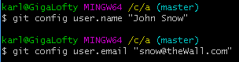

Use the git config –list to confirm that the name and email address have been set.
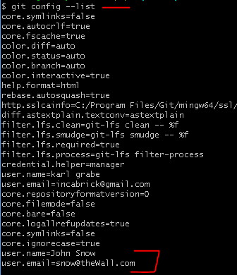

Initializing Git repository

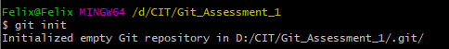

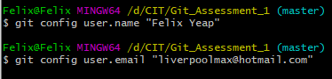

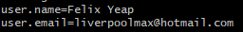

(a) Create a very basic HTML home page document for the newly-formed Munster Technological University. The page contains the name “Munster Technological University” and its address. Create and configure a git-managed repository and commit your initial version of the page.

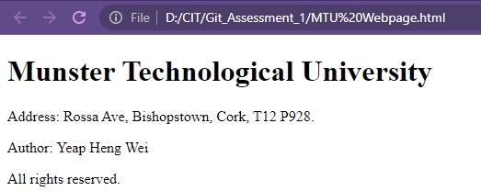
Initial website is created.

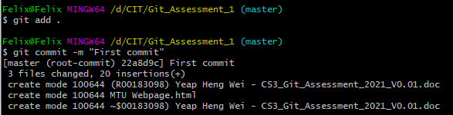

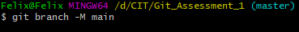

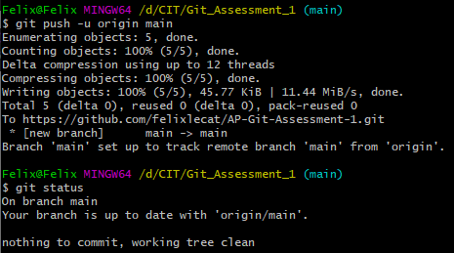
First commit is done
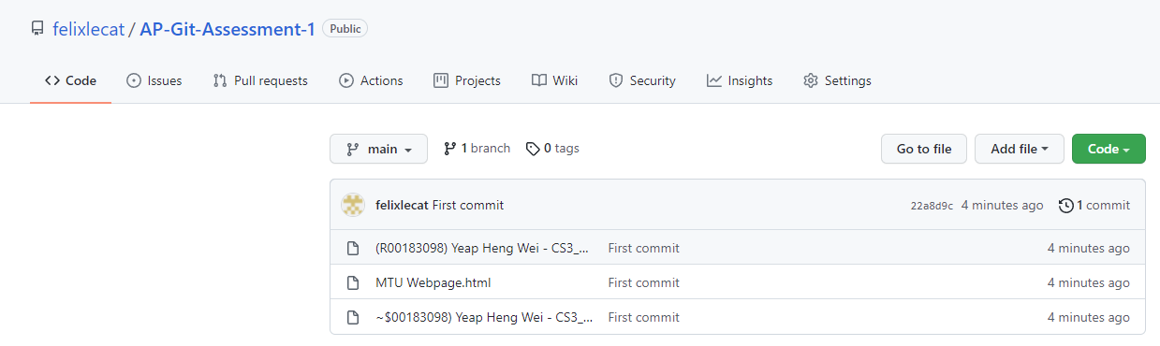
Files of first commit in GitHub

(b) Add items to the web page, each time committing to the repository. In total, create and commit 5 variations of your web page. Consider the following example items-to-add: About, Latest News, Contact Details, University Philosophy, University Vision.

(c) Add a second file to the repository e.g. a css file to change the look of the page. Commit that css file; also commit two revisions of the css file.

Additionally, revise the web page html code to use the css file. Commit your revised web page. Thus, there are now 7 versions of the web page.

(d) Demonstrate rolling back to view version 4, of the web page.

Create a branch from version 6; on your branch, modify the web page in order to demonstrate a new variation for the customer.

(e) Demonstrate merging, versioning and stashing

(f) Execute the following git commands & include screen shot(s) of all output generated.
git config –list
git log

The End!

